Name: Mohammad Rohaan Section: E Date:11/03/2026

Wiegers Requirement Prioritization

Scenario: A University wants to develop a University Course Registration System that will allow students to manage their courses online. The system should simplify course selection, registration, and academic management.

Stakeholder: University Administration (Registrar Office)
Their goal is to manage course registration efficiently and avoid scheduling or enrollment issues.

Requirements with Justification (According to the Stakeholder)
Req | Requirement | Relative Benefit |  | Relative Detriment | Stakeholder Reason
R1 | Students can view available courses | 6 | 3 |  | Helpful for students but the university can still publish course lists through other channels (email/notice boards).
R2 | Students can register for courses online | 9 | 7 |  | Core functionality. It automates registration and reduces manual workload for the administration.
R3 | Students can drop or swap courses | 4 | 7 |  | Useful feature, but if missing it creates many manual requests and administrative burden.
R4 | Students can view their timetable | 2 | 1 |  | Convenient feature but not critical since timetable could be shared through PDFs.
R5 | Students receive deadline notifications | 4 | 9 |  | Not implementing it can cause students to miss deadlines, creating complaints and administrative problems.
R6 | Students can view prerequisites and eligibility | 4 | 8 |  | Important to prevent students from registering in incorrect courses which can create academic issues later.

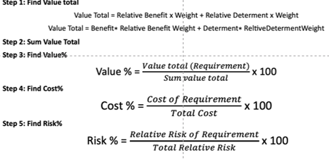
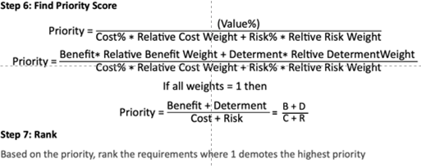

Time | 2 | 0.5 |  |  | 1 |  | 1
Requirements | Relative Benefit | Relative Detriment | Value Total | Value% | Relative Cost | Cost% | Relative Risk | Risk% | Priority | Rank
R1 | 6 | 3 | (6×2) − (3×0.5) = 10.5 | 25.9 | 2 | 11.1 | 1 | 7.7 | (6+3)/(2+1) = 3.0 | R1
R2 | 9 | 7 | (9×2) − (7×0.5) = 14.5 | 35.8 | 4 | 22.2 | 2 | 15.4 | (9+7)/(4+2) = 2.67 | R2
R3 | 4 | 7 | (4×2) − (7×0.5) = 4.5 | 11.11 | 4 | 22.2 | 2 | 15.4 | (4+7)/(4+2) = 1.83 | R6
R4 | 2 | 1 | (2×2) − (1×0.5) = 3.5 | 8.6 | 1 | 5.6 | 1 | 7.7 | (2+1)/(1+1) = 1.50 | R3
R5 | 4 | 9 | (4×2) − (9×0.5) = 3.5 | 8.6 | 4 | 22.2 | 4 | 30.8 | (4+9)/(4+4) = 1.63 | R5
R6 | 4 | 8 | (4×2) − (8×0.5) = 4.0 | 9.9 | 3 | 16.7 | 3 | 23.1 | (4+8)/(3+3) = 2.00 | R4
Total |  |  | 40.5 |  | 18 |  | 13

